**HowTo: transfer AMI between specific AWS Accounts**

**Copy AMI from one AWS account to another account**

AWS AMI [Amazon Machine Image]

In the full form, you will understand the use of AMI. It's basically a copy of your running EC2 Machine which we store on AWS as a backup of your machine.

You can transfer AMI with specific AWS accounts without making the AMI public. All you need are the AWS account IDs.

In this article, we are going to understand how to transfer ami or copy Ec2 instance from one Aws account to another account.

I have written this article because recently we had face one issue where we need to transfer an ec2 account from one account to another, and we struggled a lot to find a solution on this.   
So after successfully shared ec2 instance between two accounts I feel to share knowledge with you all.

Transferring or sharing Ec2 instances has few steps to follow. We can not share or copy ec2 directly first we need to take a snapshot of that ec2 instance then only you will able to share the instance.

Let’s start the process to transfer ami snapshot from one account to another aws account.

Assume that we have to share or copy ec2 from AWS-1 account to AWS-2 account.

Step 1: Login to AWS 1 Account.

First, Open the Amazon EC2 console at <https://console.aws.amazon.com/ec2/>and login to your account AWS-1.

Step 2: Make AMI

After login into your aws-1 account, you need to create AMI of EC2 instance which you would be sharing with AWS-2 Account.

To make AMI, right click on EC2 instance and go to “ **Image-->Create Image** ” then give **Image Name** and **Description** and make sure to **tick** to **No Reboot** option before creating image otherwise your ec2 server has been a reboot in the process of Create Image.

After feeling necessary information click on “ **Create Image** ” button. It will take some time to create image depends on how much storage available on the server.

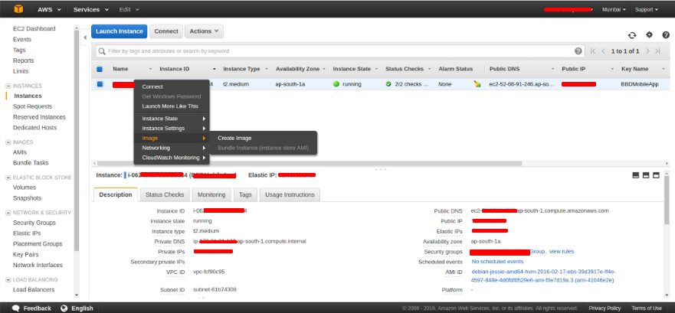

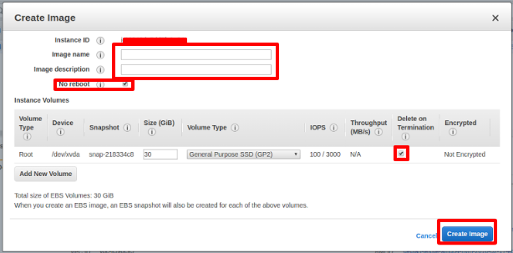

Step 3: Modify Image Permission

After completing image creation process, go to the “ **AMI** ” pane then check for your **AMI** or **image** . Right click on the image then select “ **Modify Image Permissions** ”.

It will open window to **Add Permissions** for AWS-2 Account to access the AMI.   
Under the input box, add the AWS-2 Account number where you want to transfer or share ec2 snapshot and tick on **Add volume** option then click **Save** .

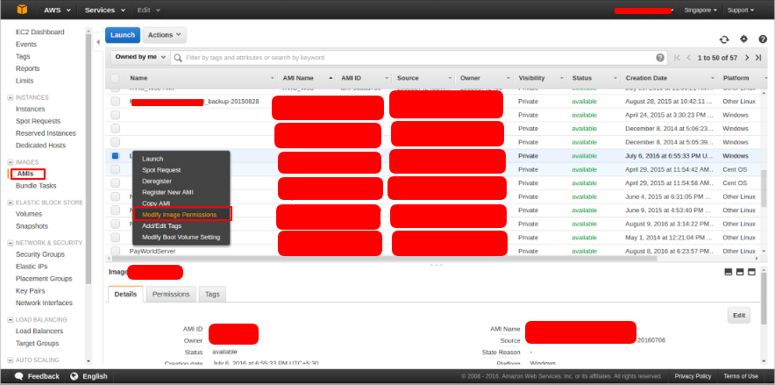

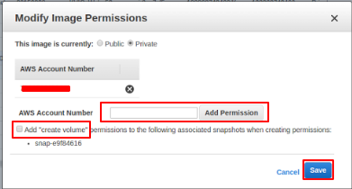

Here, we have completed the work on AWS-1 account.

Step 5: Login AWS-2 Account

In aws-2 account, Go to the “ **Services-->Ec2-->Launch** ” once you click on launch button you will have a panel to start new instance.

In the right side pane select “ **My AMIs** ” and under the Ownership select “ **Shared with me** ”.

**Copy AMI ID** of a snapshot from AWS-1 account then pastes it in “ **Search my Ami’s** ” then you will find your snapshot just simply launch this snapshot, and you will have your EC2 instance in AWS-2 Account.

If you don’t know how to launch ec2 instance refer below link:

[How to Launch Ec2 instance in Amazon?](http://www.techthings.org/steps-to-launch-your-first-ec2-instance-on-amazon-cloud/)

